Use case Create customer Profile: Simple
First cut design class diagram:
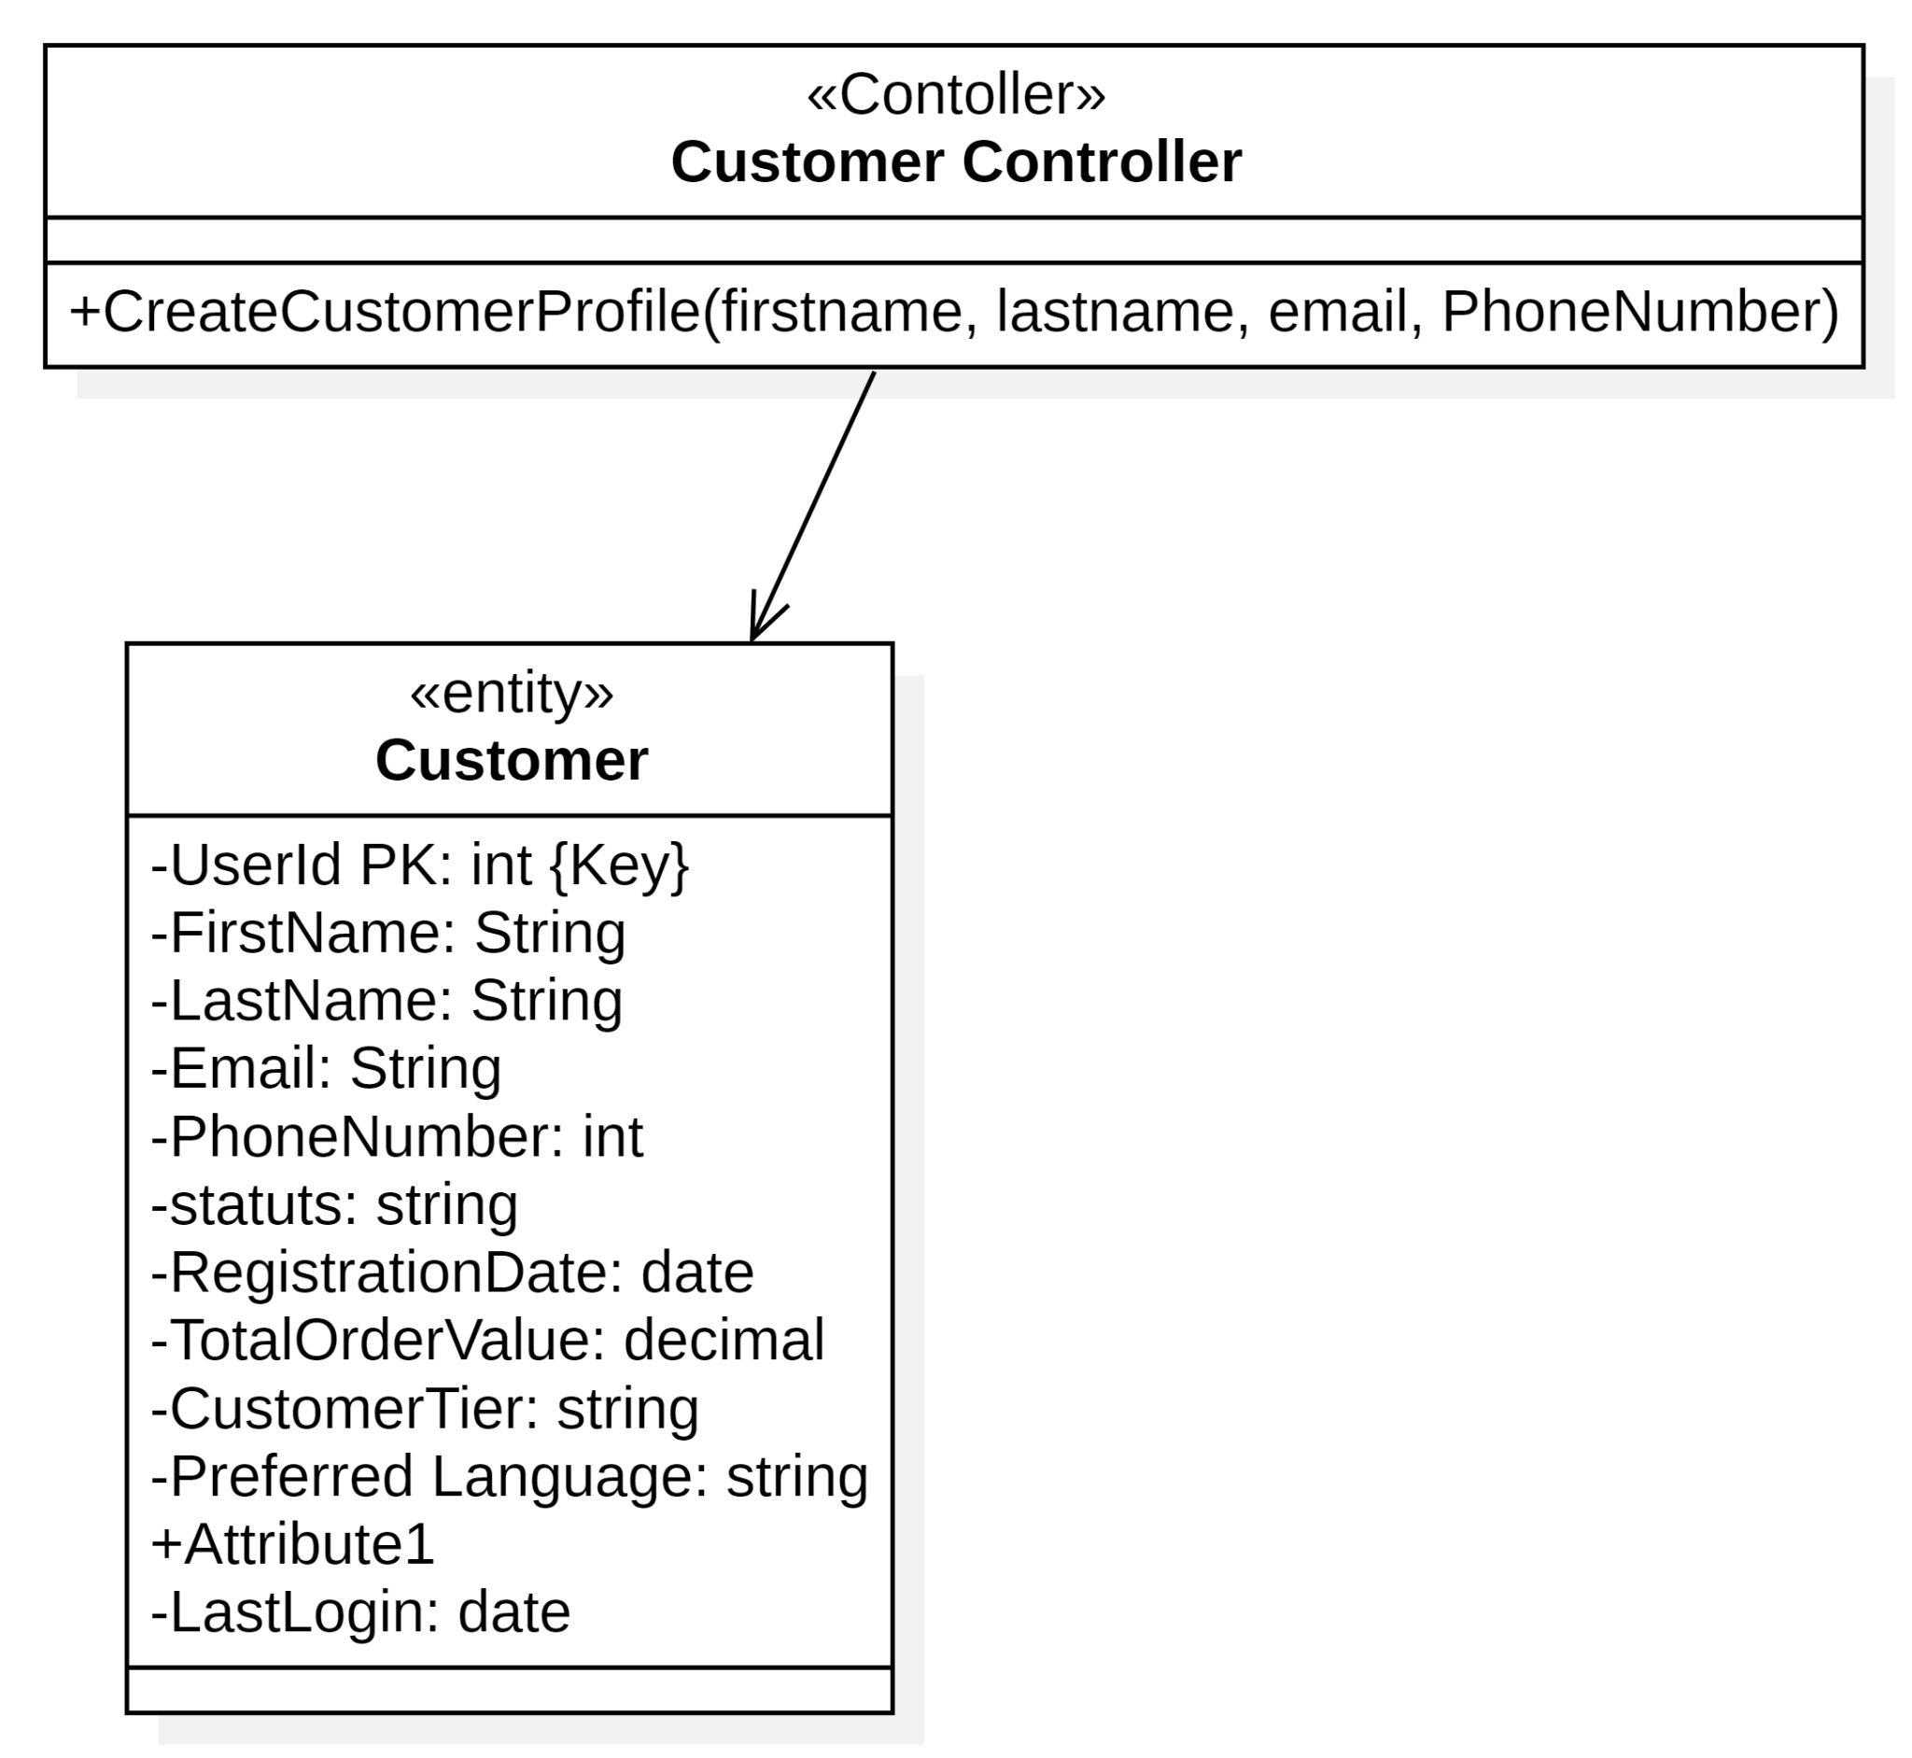
CRC:
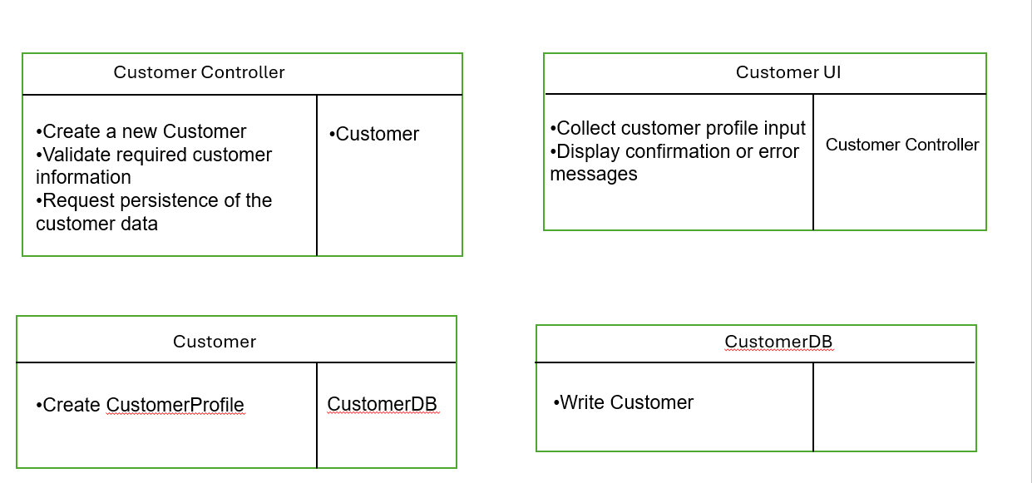

Final Design class Digram:
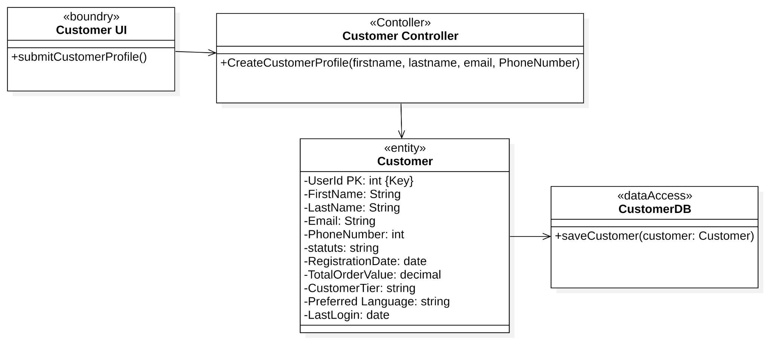

Use Case: Retrieve Customer Information :Moderate
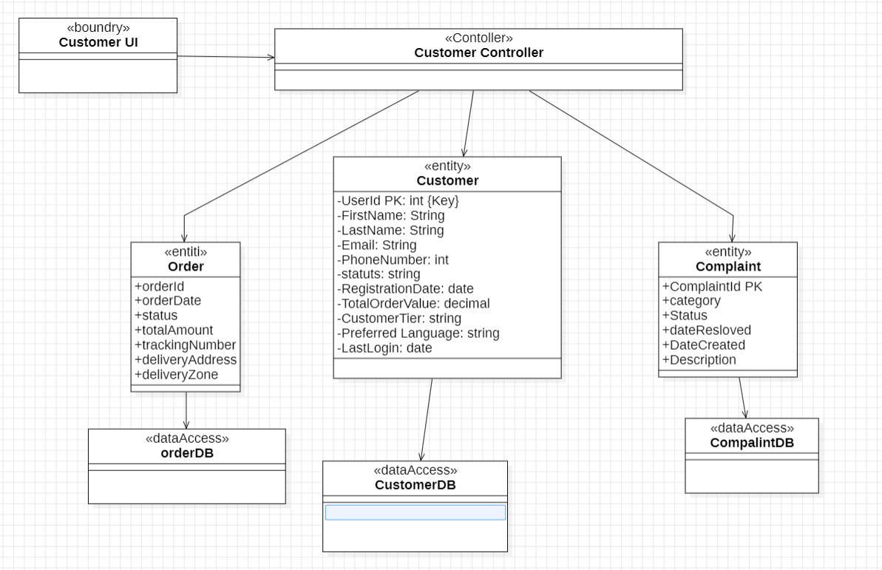
First Cut Design Class diagram:

Communication Diagram:
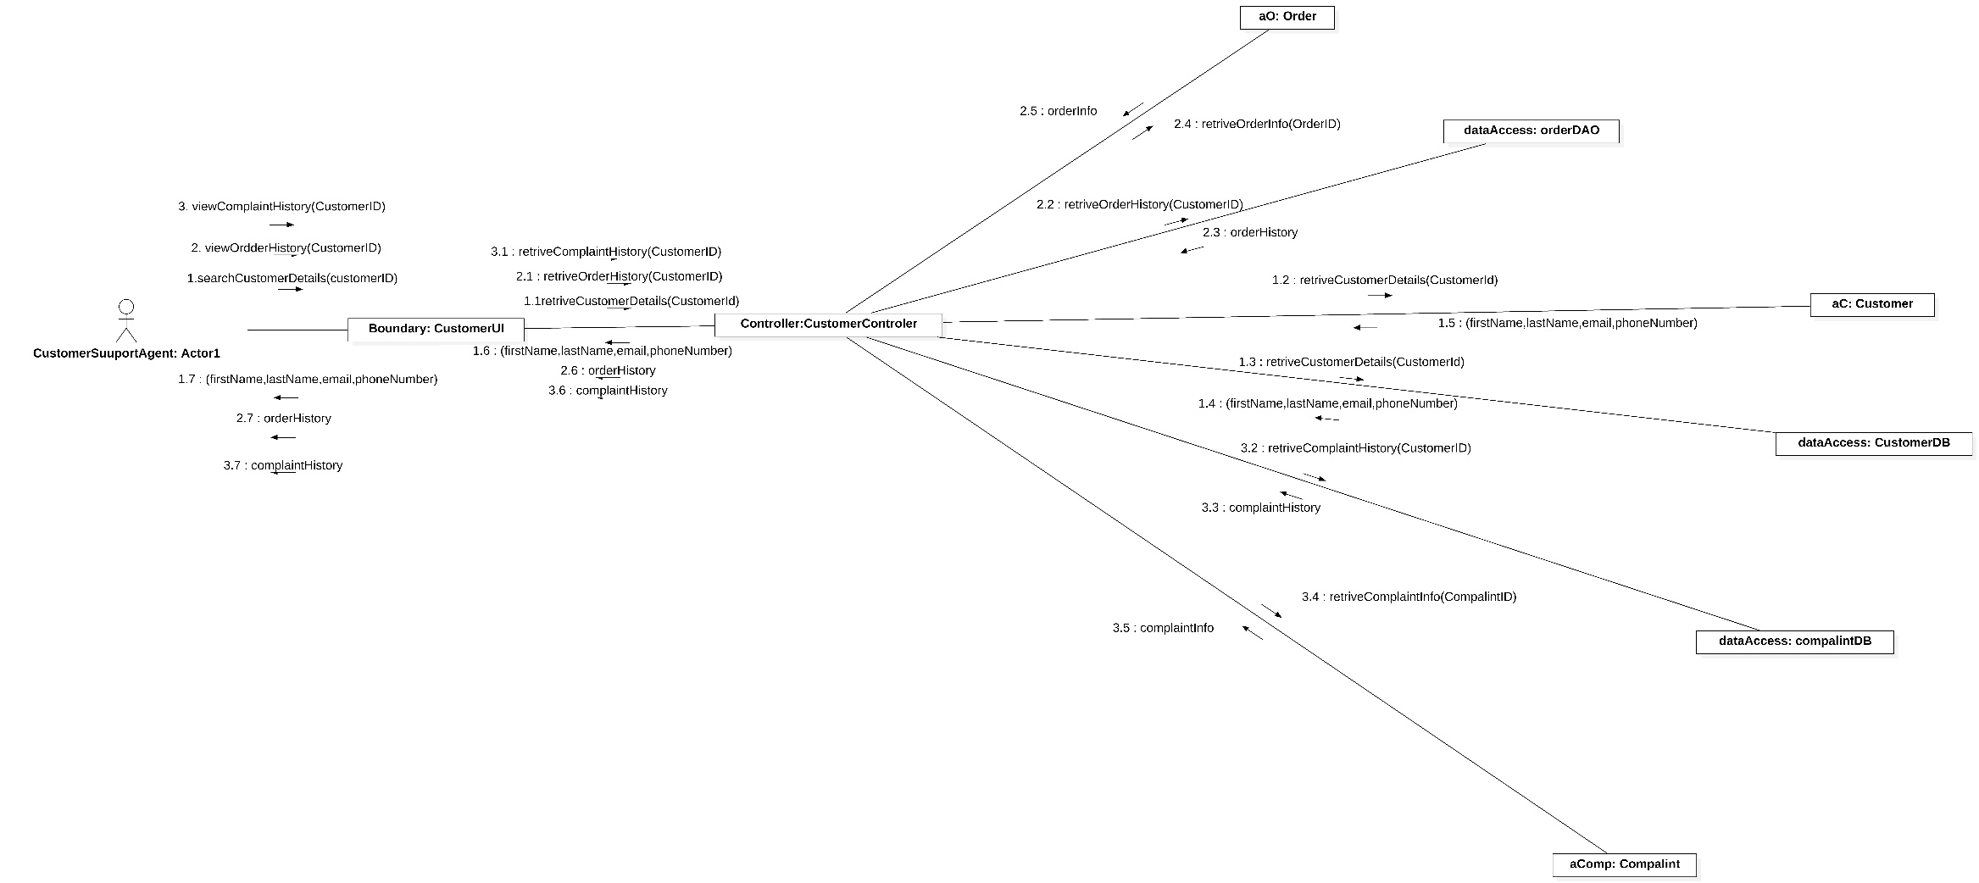

Final design Digram:

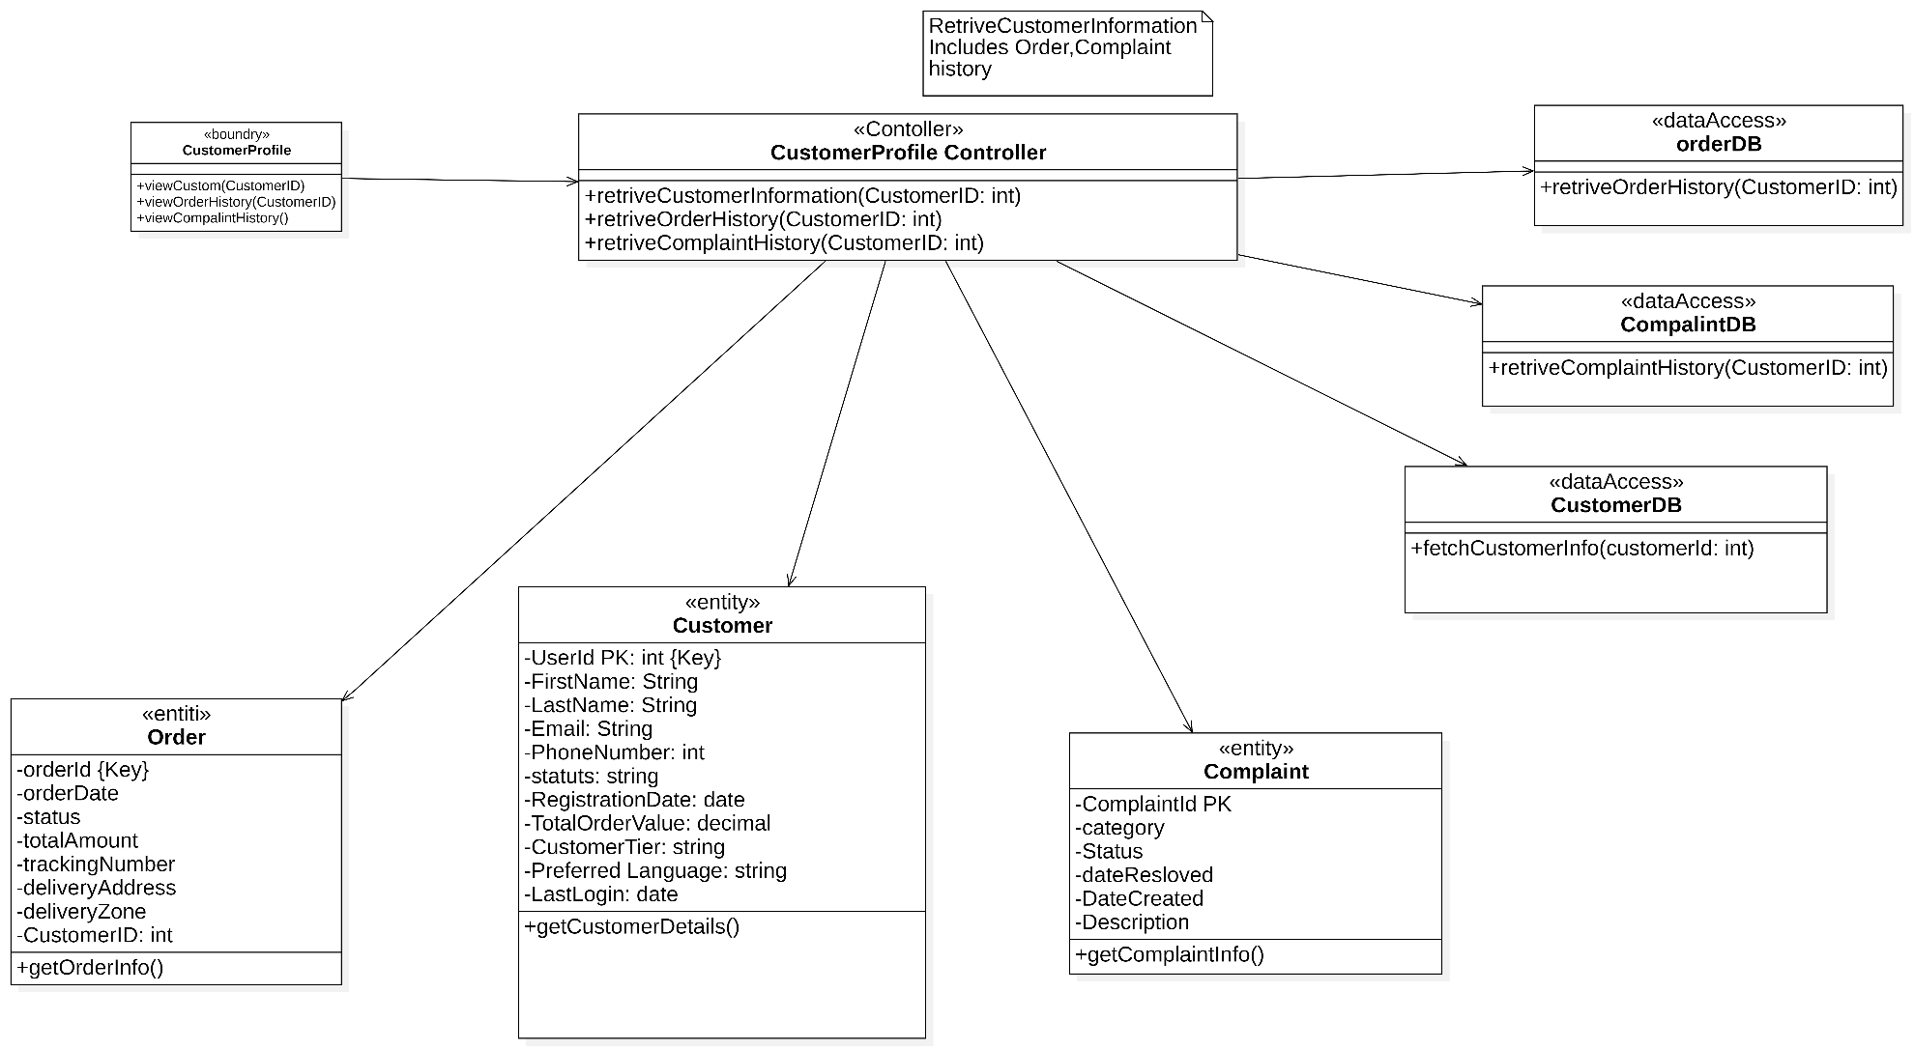

Update customer status:

First cut edge:

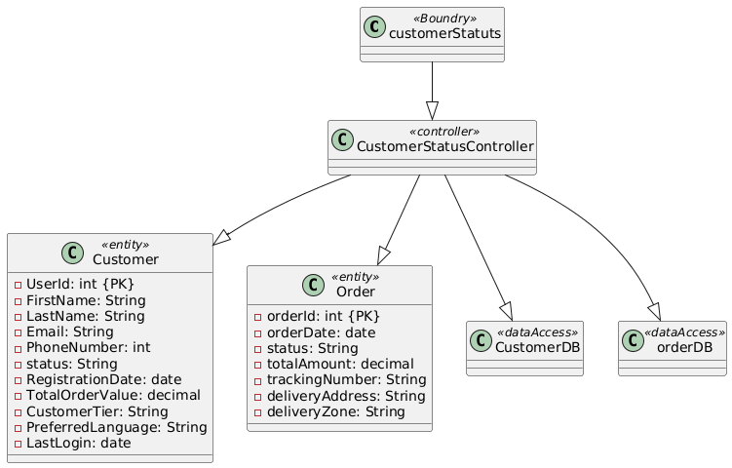

Multi layer sequence diagram:
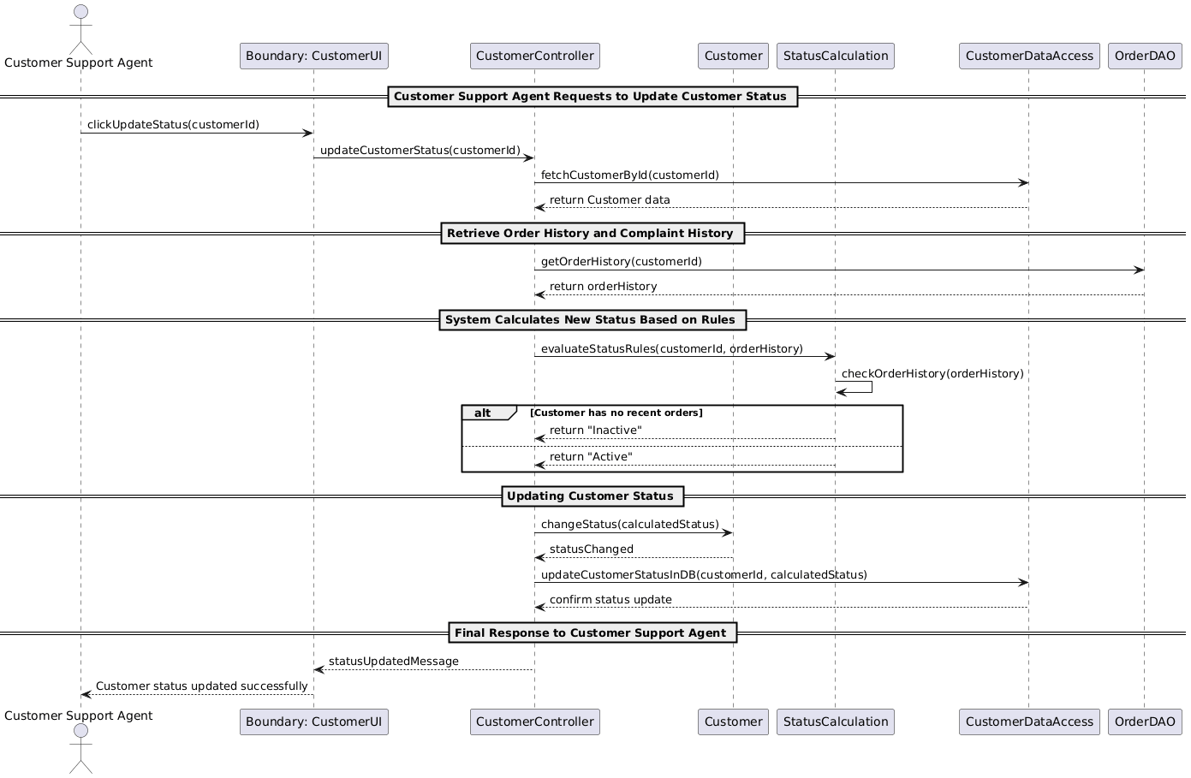

Final design :
